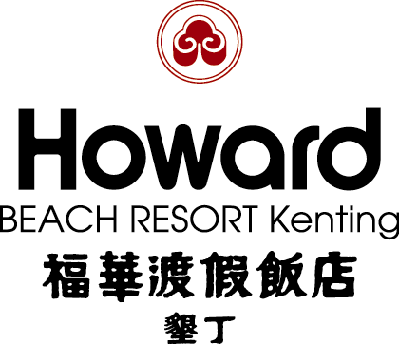
ACTSEA 2011 International Symposium on Advanced Ceramics and Technologies for Sustainable Energy Applications

Reservation Form
DO NOT WRITE IN THIS SPACE
Hotel use only
Reservation No. |  | Security deposit | NT$
※To ensure your rights, please be sure to fill out the following information:
Name |  | E-mail
Telephone |  | Check in date |  | Check out date
Fax |  | Total Amount | NT$

Room Type | Price(per room/night) | Bed Type | Room Type |  | Price(per room/night) | Bed Type
Howard Single Ocean | □NT$4,200(one person) | one luxurious bed | Deluxe Twin |  | □ NT$2,800(one person) | one luxurious bed
Howard Single Ocean | □NT$4,400(two persons)
Howard Twin Ocean | □NT$4,200(one persons) | two luxurious beds |  |  | □ NT$3,000(two persons) | two luxurious beds
Howard Twin Ocean | □NT$4,400(two persons)
Howard Twin Ocean | □ NT$4,900(three persons) | two luxurious beds |  |  | □ NT$3,500(three persons) | two luxurious beds
Howard Twin Ocean | □ NT$5,400(four persons) | two luxurious beds |  |  | □ NT$4,000(four persons) | two luxurious beds
Deluxe Triple | □ NT$4,500(five persons) | three luxurious beds | Deluxe Triple | □ NT$3,500(three persons) |  | three luxurious beds
Deluxe Triple | □ NT$5,000(six persons) | three luxurious beds | Deluxe Triple | □ NT$4,000(four persons) |  | three luxurious beds
*Surcharge NT$2,000 per room/night for staying on the weekend(Oct.29,Nov.05).
Notes:
＊All rates include breakfast, tax , and service charge.
＊Check-in: 15:00 & Check-out: 12:00
＊Payment can only be made by credit card (only Visa, Master, JCB, American Express can be accepted)
＊Special offer is limited. Please make your reservation before Oct 05.2011.
＊Reservations and room allocation for any of the requested room type will be done on “First come, First serve” base along with the first night deposit. Please kindly provide your credit card details to guarantee your reservations. Any no-show or cancellation of reservations within 72 hours, one night deposit will not be refunded.
Payment:
＊Credit Card：Please fill out the reservation form and copy the credit card for both side , then fax
it to Sally Chen (Fax no.: +886-8-8862240)

Visa/Master Cardholder Authorization Letter
Please provide the hotel with your credit card details. The details are used for reservation purposes only.
Name (as shown in credit card) |  | Telephone
Card Type | □VISA □MASTER/DINERS □JCB Card □American Express
Credit Card No.
Expiration Date（MM/YYYY） |  |  | Security deposit |  | NT$
Security Code | □ □ □ (Last 3 digits security code on the back of the card)
Card Holder’s Signature | (Signature should be as SAME as it shown on your credit card)
~ Please bring this form to check in, thank you very much~

